**FOURIER SERIES**

**LAB # 09**



**Spring 2022**

**CSE301L Signals & Systems Lab**

Submitted by: **Ebtihaj Abdullah**

Registration No. : **20PWCSE1885**

Class Section: **A**

“On my honor, as student of University of Engineering and Technology, I have neither given nor received unauthorized assistance on this academic work.”

Student Signature: ______________

Submitted to:

**Engr. Durr-e-Nayab**

Wednesday, June 25, 2022

**Department of Computer Systems Engineering**

**University of Engineering and Technology, Peshawar**

## Lab Objective(s):

Objectives of this Lab are;

* Power of Continuous & Discrete time Signals •
* Application of Fourier Series
* Synthesis of Square Wave
* Synthesis of Triangular Wave

## Task # 01:

Calculate the power of discrete‐time cosine signal with period 20, defined over interval 0:19 using the following formula:

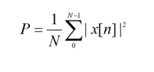

**Problem Analysis:**

We have to make a signal ranging in a specific time interval

**Algorithm:**

* Write code
* Execute Code
* Record Results

**Code:**

*t=0:0.001:19;*

*ff=2;*

*x=cos(2*pi*ff*t);*

*figure(1)*

*plot(x);*

*z=abs(x);*

*z1=z.*z;*

*xt2=sum(z1)*0.001/20;*

*xt2*

**Output / Graphs / Plots / Results:**

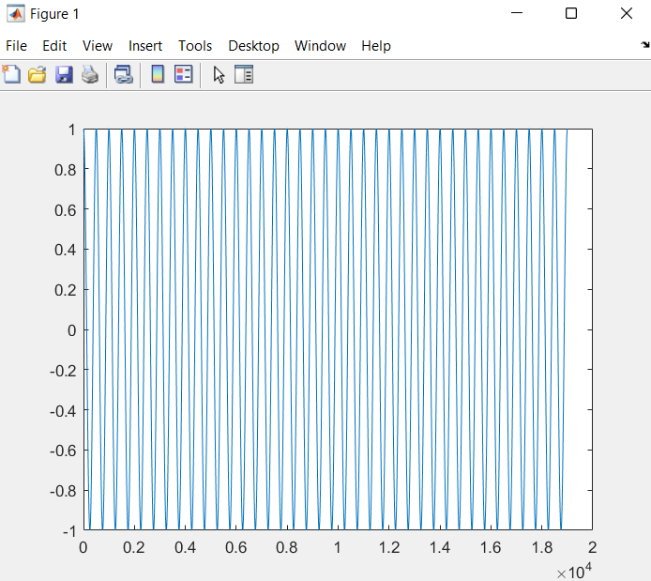

**Discussion and Conclusion:**

We can make desired signals in MATLAB

## Task # 02:

Analyze the effect of Adding 1st to 17th harmonics and the effect of Adding 1st to 27th harmonics in above example.

**Problem Analysis:**

To add harmonics and analyze the square wave function.

**Algorithm:**

* Write code
* Execute Code
* Record Results

**Code:**

*clc*

*clear all*

*close all*

*t=0:0.0001:8;*

*ff=0.5;*

*y = (4/pi)*sin(2*pi*ff*t);*

*for k = 3:2:34;*

*fh=k*ff;*

*x = (4/(k*pi))*sin(2*pi*fh*t); y=y+x;*

*end*

*plot(t,y,'linewidth',1.5);*

*title('A square wave with harmonics 1st, 3rd, 5th, and 7th upto 17th'); xlabel('Time');*

*ylabel('Amplitude');*

**Output / Graphs / Plots / Results:**

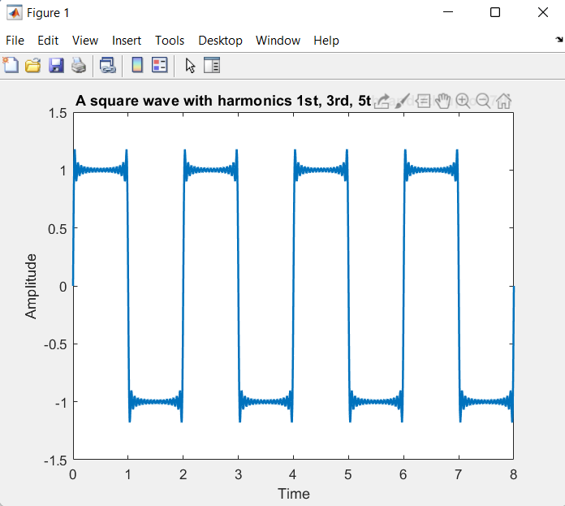

**Discussion and Conclusion:**

We can add more and more harmonics to a square wave under gibbs effect.

## Task # 03:

Write a program that plots the signal s(t).

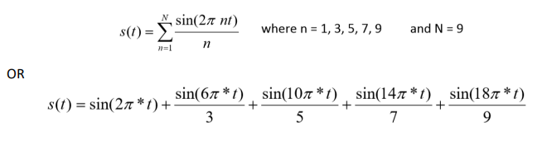

**Problem Analysis:**

To create a signal with above values.

**Algorithm:**

* Write code
* Execute Code
* Record Results

**Code:**

t=0:0.01:10;

s=sin(2*pi*t)+((sin(6*pi*t))/3)+((sin(10*pi*t))/5)+((sin(14*pi*t))/7)+((sin(18*pi*t))/9);

plot(s);

**Output / Graphs / Plots / Results:**

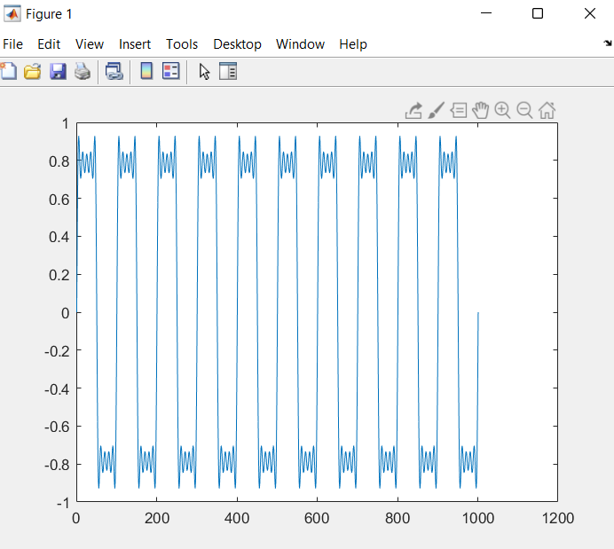

**Discussion and Conclusion:**

We can make new signals with our desired values.

## Task # 04:

Generate a triangular wave with N=11

**Problem Analysis:**

To change N factor of a triangle wave

**Algorithm:**

* Write code
* Execute Code
* Record Results

**Code:**

*clc; clear all; close all*

*t=0:0.001:5;*

*x=(-8/(pi*pi))*exp(i*(2*pi*0.5*t));*

*y=(-8/(111*pi*pi))*exp(i*(2*pi*0.5*11*t));*

*s=x+y;*

*plot(t,real(s),'linewidth',3);*

*title('Triangular Wave with N=11');*

*ylabel('Amplitude');*

*xlabel('Time')*

**Output / Graphs / Plots / Results:**

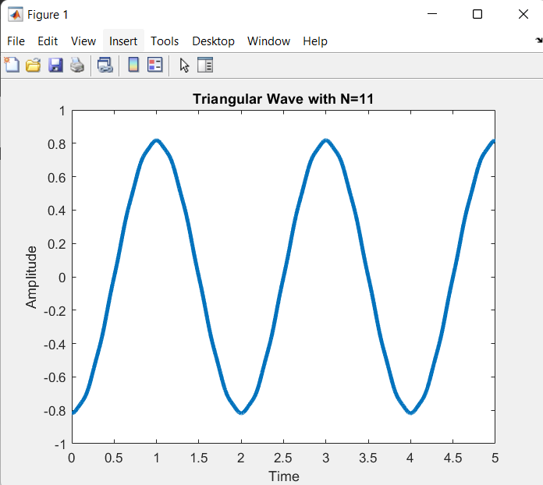

**Discussion and Conclusion:**

Hence we can modify different signal waves